# Database Scripts

## Steps to execute a script file in Dbeaver Tool

1. Open the script in “Dbeaver Tool” by clicking on menu “SQL Editor🡪Import SQL Script” and selecting the script file
2. Execute the script file by pressing key “Alt X” or clicking on below blue coloured circle icon

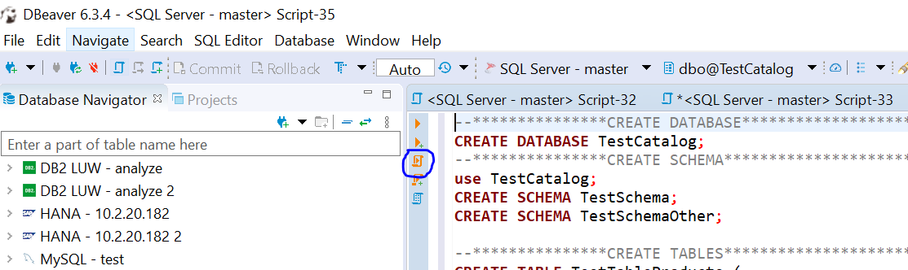

## Steps to execute create database script

1. Login with “mssqltest” user in sql server database.
2. Create database “TestCatalog” and user “dberman” by executing script file “CreateDatabaseAndUser.sql”.
3. Login with user “dberman” with password “dberman”.
4. Create database objects like table, view, function, procedure and objects by executing script file “CreateObjects.sql”

## Steps to execute drop database script

1. Login with user “dberman” with password “dberman”.
2. Drop database objects like table, view, function, procedure and objects by executing script file “DropObjects.sql”.
3. Login with “mssqltest” user in sql server database.
4. Drop user “dberman” and database “TestCatalog” by executing script file “DropDatabaseAndLogin.sql”.